Lab 7: Analysis of Variance

Over the past two labs, you have completed inferential analyses to determine whether two groups of students’ data represented statistical differences. Specifically, we looked at two independent groups (i.e., females and males) and two dependent groups (i.e., pre- and post-test scores). In this lab, we will investigate an inferential analysis technique on two or more groups of students.

1. One-way ANalysis Of VAriance (ANOVA): first languages
You would like to revisit one of your previous research studies (lab 4, section 4) in which you answered the research question: Do students who speak different first languages perform differently on a reading achievement test? This time, please run a one-way ANOVA to indicate whether or not there are differences among students who speak a different first language. In order to run a one-way ANOVA on this sample of students, click Analyze → Compare Means → One-Way ANOVA → move READING_LECTURE into Dependent List → move SQ04 into Factor → click Post Hoc and check off Scheffe and Tukey → Continue → click Options and check off Homogeneity of variance test, Brown-Forsythe, and Welch → Continue.
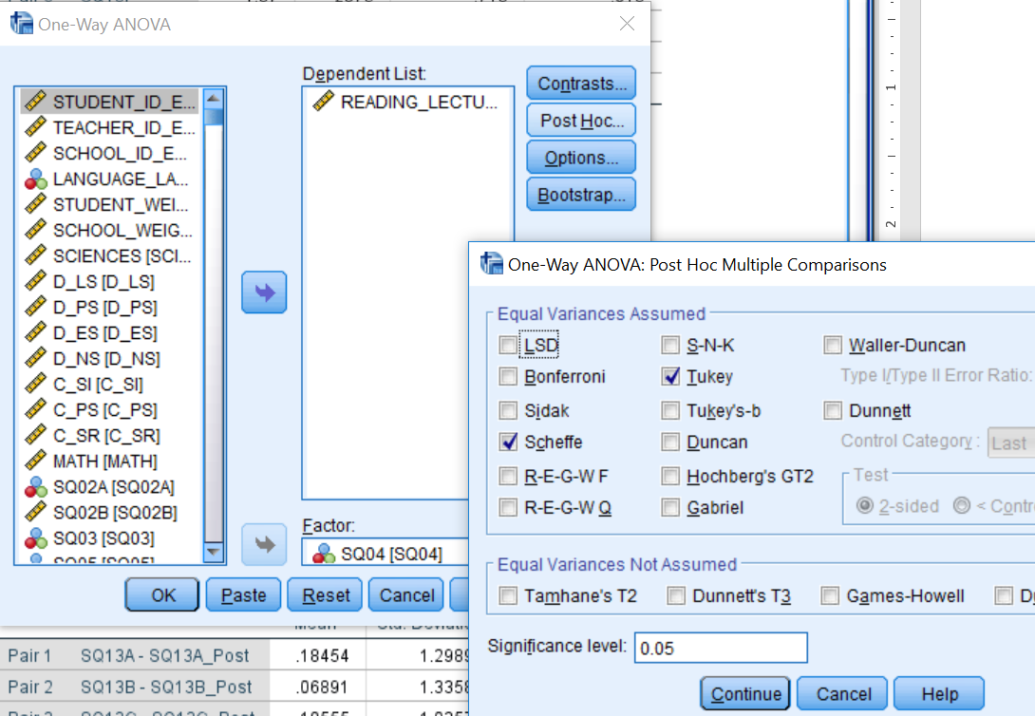
Question:
- Please write the null hypothesis and alternative hypothesis for the new research problem.
- There are three basic assumptions that should be considered before running an ANOVA:
- independence of sample – In one short sentence please explain how your sample satisfies this assumption
- normality – Does your sample violate the normality assumption (if you have forgotten how to test for normality, please refer to lab 5, section 1, page 2, as well as questions 3, 4, and 5)?
- homogeneity of variance – You have already run three homogeneity of variance tests (Levene, Welch, and Brown-Forsythe). Which one should you report? (You may need use Google for this question.) Does your sample violate the homogeneity of variance assumption? (Please report the statistic, degrees of freedoms, and p-values in your answer using the proper format.) (If you have forgotten how to test for homogeneity of variance, please refer to lab 5, section 1, pages 3 and 4, as well as question 6.)

One-way ANOVAs are relatively robust to violations of the normality and homogeneity of variance assumptions when using a large sample size. Hence, we proceed with interpreting our analyses, but looking at the ANOVA table in our SPSS output.
Question:
- Does your ANOVA output indicate a significant difference? Please report your findings using the sentence “The ANOVA analysis indicated a statistically [significant/non-significant] difference on students’ reading achievement based on their first languages, F([df_{between}, df_{within}])=[F-value], p[</>]0.05.” Please follow APA rules when writing this sentence.
- Now we need to locate where the difference is located. Looking at the post-hoc tests, Tukey and Scheffe, which test should you use? Using the post-hoc test your chose, what do the results tell you? Please report your findings in a short paragraph (include p-values). Note: In lab 4, section 2, you developed a 95% confidence interval graph to depict this difference, you are now explaining this difference in a written format (In a publication, you would need the written format, but often a graph helps to convey the message).
- As a part of your discussion (i.e., no technical jargon), please answer your research question: Do students who speak different first languages perform differently on a reading achievement test? (You have already completed a portion of this question in lab 4, section 4. This is an opportunity for you to improve your discussion of the results.)

2. One-way ANalysis Of VAriance (ANOVA): socioeconomic statuses
Please revisit your previous analyses of the research question: Do students who are at a higher SES, as measured by the number of books in their home, perform better on a general science achievement test (no subtests)?
Question:
- Please complete an ANOVA analysis for this research question. As you answer the research question, please use questions 2, 3, and 4 (from above) to guide you through the different elements to report. Your answer to this question can only be a maximum of five sentences, so report only the most important pieces of information for your readers.

3. One-way ANalysis Of VAriance (ANOVA): mother’s highest level of education
You have been doing some research, and you come across a very interesting theory that the highest level of education of the female caregiver influences the child’s science achievement. You are interested in testing this theory using the PCAP 2013 data, because the data set has information regarding students’ mothers’ highest level of education (i.e., SQ09) and their academic achievement (i.e., overall science, math, and reading achievement). Your research question is: Do students’ mothers’ highest level of education influence their performance on academic achievement tests?
Questions:
- Please complete full analyses for this research question. As you answer the research question, please provide: (a) descriptive analyses by group represented in a table and a brief paragraph, (b) results of the assumption analyses (these are often reported in 1–2 sentences), (c) inferential analyses (i.e., results of the ANOVA) represented in a table and a brief paragraph (please complete question 8 before you answer this question), and (d) a discussion paragraph in which you answer the research question without technical jargon (please include post-hoc results, as well).
- What alpha value should you use? Since you have completed three ANOVA analyses (i.e., one for each of the overall subscale scores), you will need to do a Bonferroni correction (If you have forgotten how to complete this, please refer to lab 6, question 6).

You have now completed the lab.

